**Group 6: PROgrammers**

Group Captain: Yessica Rodriguez 0414909

Oscar Torres 463454

Daniela Tamayo 20336461

Ulvi Bajarani 20539914

1. **PROBLEM STATEMENT**

With advances in technology, the usage of the internet has increased. People use the internet to shop, conduct research, get entertained, and more. No longer do ads in the newspaper work. However, it is not easy to find someone who offers more household or “handyman” services on the internet or for these people to find customers. Therefore, in this project, an application, ***HomeNeedsService.com***, will be created to provide a platform for users to schedule providers for these services. In the application, the user will be able to search a service and enter all the necessary information to schedule the service. The information would include the location, time, and date. Once that is completed, providers of the service that have an account in this application and are available during the scheduled time will be notified. A provider will take up the accept the offer and the user will receive confirmation. This application will be connected to a database that will contain all necessary information.

1. **DATABASE DESIGN**

The database created is a relational database consisting of 22 tables. An Entity-Relational (E-R) Model was created to map out the relationship between each entity or table in the database. The model is shown in Figure 1.

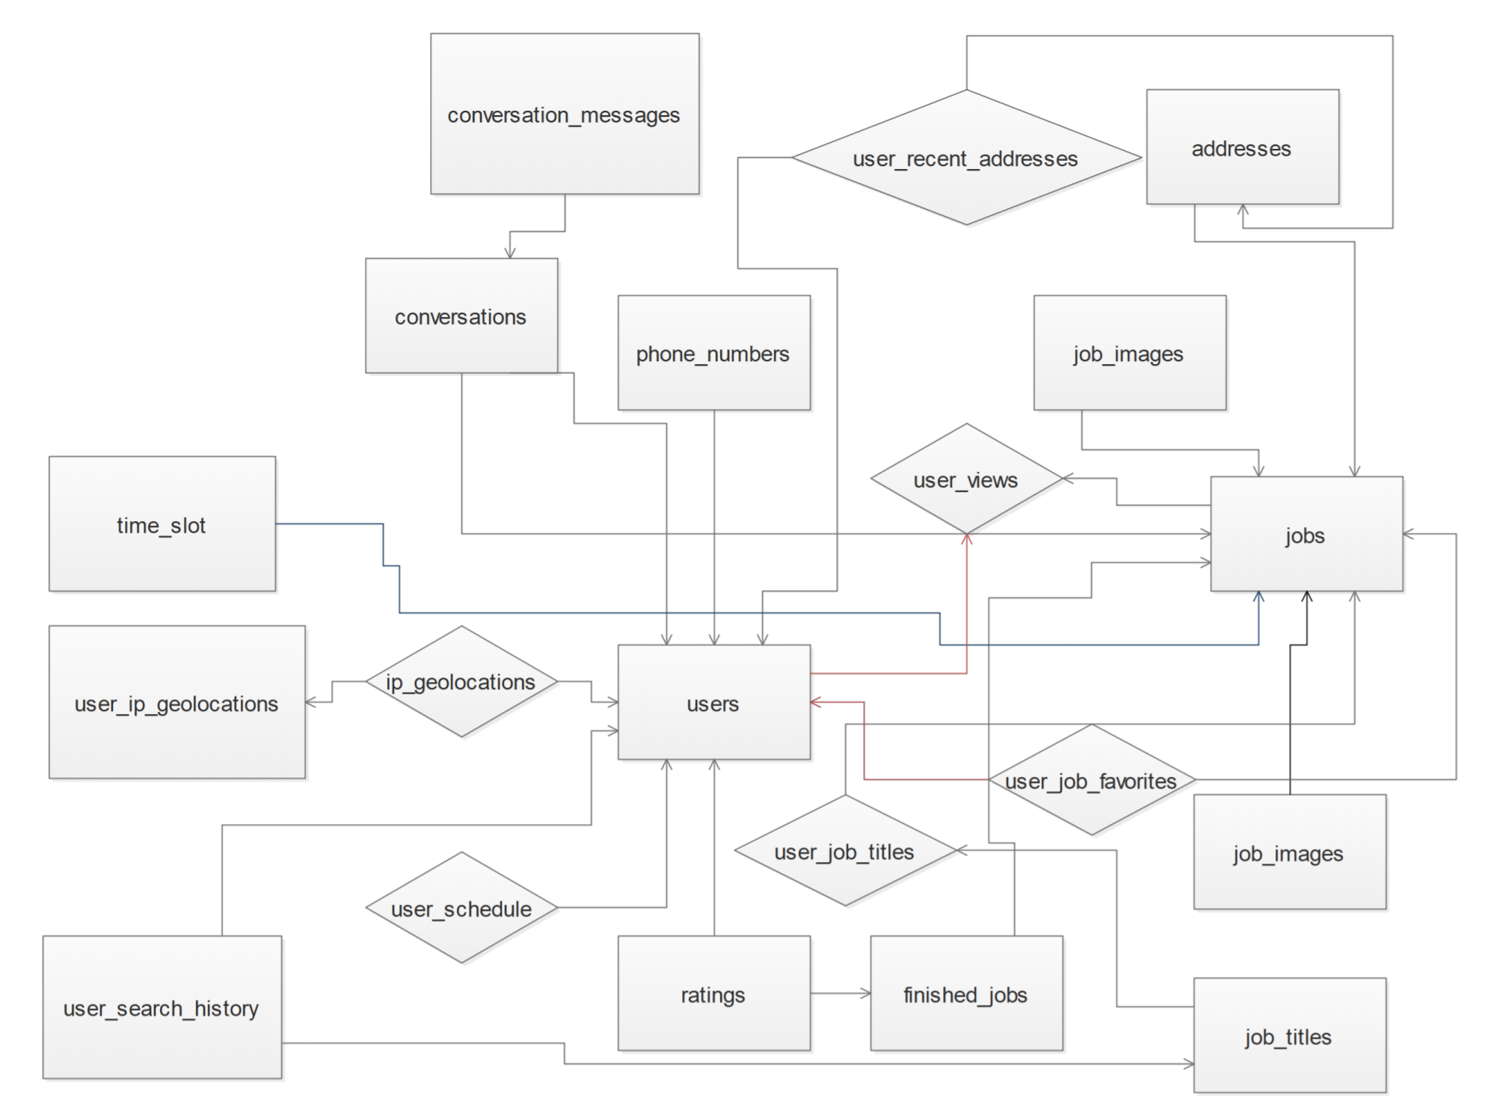

**Figure 1:** E-R Model

Using this model, the database was created. The schemas of those tables and their relations are shown in Figure 2.

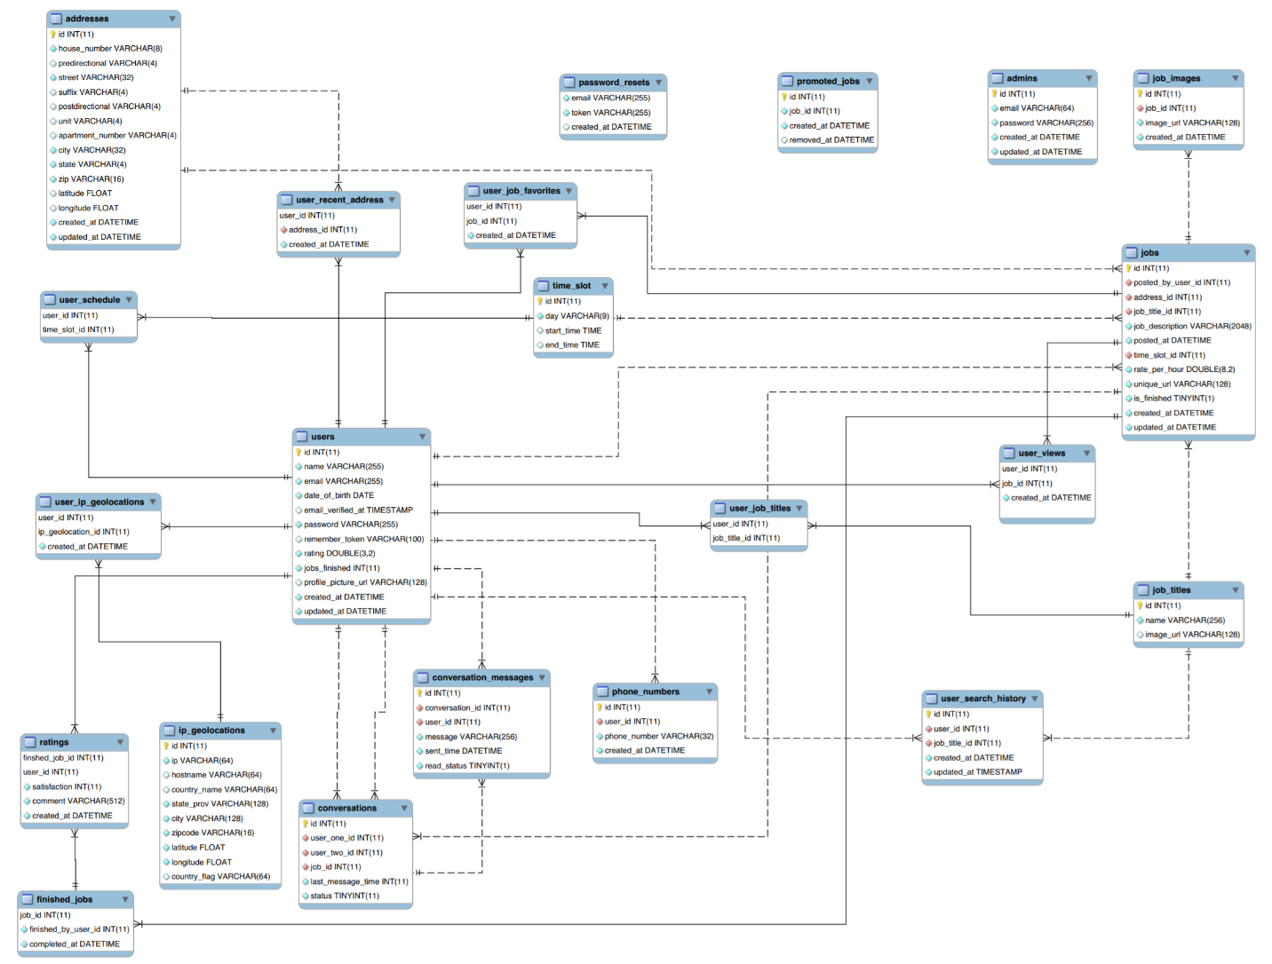

**Figure 2:** The Relational Diagram of The Database

The A brief description of each table is provided below:

**addresses:**

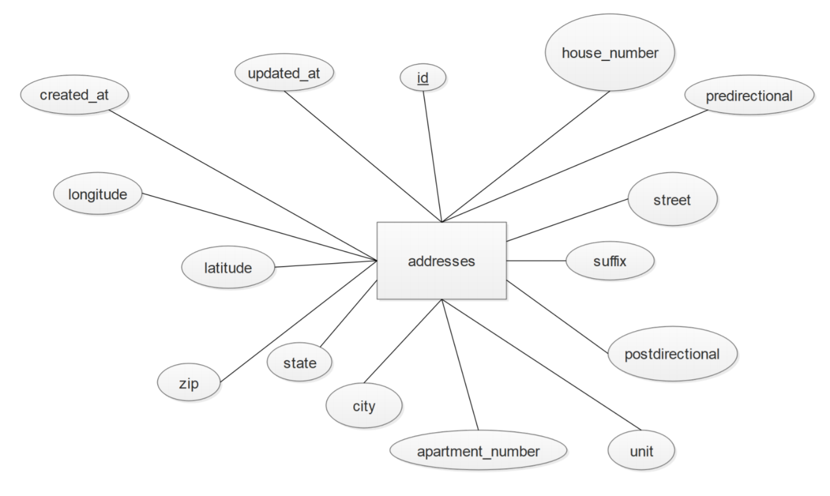

**Figure 3:** addresses Table Diagram

Description: The addresses table stores information of all addresses of each user and job. Each user can have many addresses. And each address can have many jobs. The “addresses” table is involved in a one-to-many relationship with the jobs table. This means that one address may have many “jobs.”

*id:* This is the primary key for the addresses table. Type: Integer(11)

*house_number:* This is the house number for the particular address. Type: Text(8)

*predirectional:* This is the predirectional, if there is one, for the particular address. Type: Text(4)

*street:* This is the street name for the particular address. Type: Text(32)

*suffix:* This is the suffix, if there is one, for the particular address. Type: Text(4)

*postdirectional:* This is the postdirectional, if there is one, for the particular address. Type: Text(4)

*unit:* This is the unit, if there is one, for the particular address. Type: Text(4)

apartment_number: This is the apartment number, if there is one, for the particular address. Type: Text(4)

*city:* This is the city name for the particular address. Type: Text(32)

*state:* This is the state name for the particular address. Type: Text(4)

*zip:* This is the zip code for the particular address. Type: Text(16)

*latitude:* This is the latitude value for the particular address. Type: Float

*longitude:* This is the longitude value for the particular address. Type: Float

*created_at:* This is the date and time the particular address was created. Type: Datetime

*updated_at:* This is the date and time the particular address was updated. Type: Datetime

**user_schedule:**

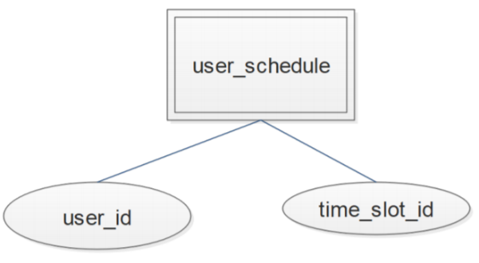

**Figure 4:** user_schedule Table Diagram

Description: The user_schedule table stores information of all the time slots that a user is available. Each user can have many time slots. And each time slot can be applicable for many users. This means that many users can be available at the same time slots.

*user_id:* This is the user id of the user that is available at the particular time slot. Type: Integer(11)

*time_slot_id:* This is the time slot id of the time slot that the particular user is available for. Type: Integer(11)

**user_ip_geolocations:**

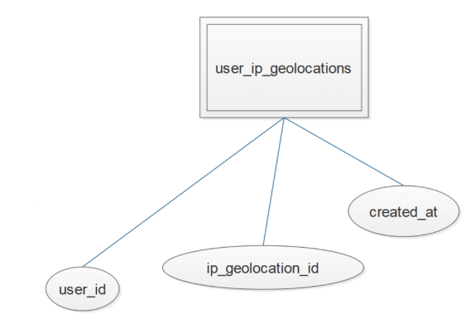

**Figure 5:** user_ip_geolocations Table Diagram

Description: The user_ip_geolocations table stores the information of the IP each user gets when accessing the website. Each user can have many accessing coordinates. Each time a particular user access the website, the website is provided with the new pair of coordinates, latitude and longitude of that IP address, as well with the date and time this happened.

*user_id:* This is the user id of the user that is accessing the website. Type: Integer(11)

*ip_geolocation_id:* This is the id of the ip_geolocation provided when accessing the website. Type: Integer(11)

*created_at:* This is the date and time the website was visited by that particular user. Type: Datetime

**ip_geolocations:**

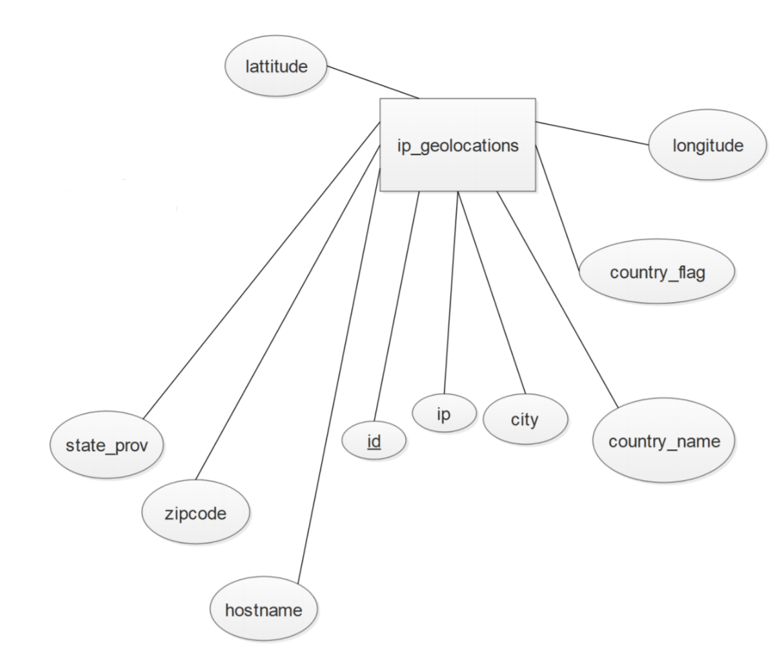

**Figure 6:** ip_geolocations Table Diagram

Description: The ip_geolocations table stores the information that helps to determine the users’ location. Each user can log in from many locations. It helps regulate the distance requirement set by each user as well. Each time the users access the website, the website is provided with the pair of coordinates, latitude and longitude of that IP address.

*id:* This is the primary key for the ip_geolocations table. Type: Integer(11)

*ip:* This is the IP address provided when the user accesses the website. Type: Text(64)

*hostname*: This is the hostname provided when the user accessees the website. Type: Text(64)

*country_name:* This is the country name of the IP address provided. Type: Text(64)

*state_prov:* This is the state name of the IP address provided. Type: Text(128)

*city:* This is the city name of the IP address provided. Type: Text(128)

*zipcode:* This is the zip code of the IP address provided. Type: Text(16)

*latitude:* This is the coordinate value of the origin of the IP address. Type: Float

*longitude:* This is the coordinate value of the origin of the IP address. Type: Float

*country_flag:* Type: Text(64)

**user_recent_address:**

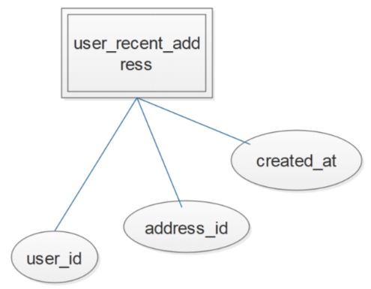

**Figure 7:** user_recent_address Table Diagram

Description: The user_recent_address table stores information of all the addresses used recently by the users. Each user could have recently used many addresses. And each address could have been recently used many times.

*user_id:* This is the user id of the user that has recently used the particular address. Type: Integer(11)

*address_id:* This is the address id of the address recently used by the particular user. Type: Integer(11)

*created_at:* This is the date and time that the particular address was used by the particular user. Type: Datetime

**users:**

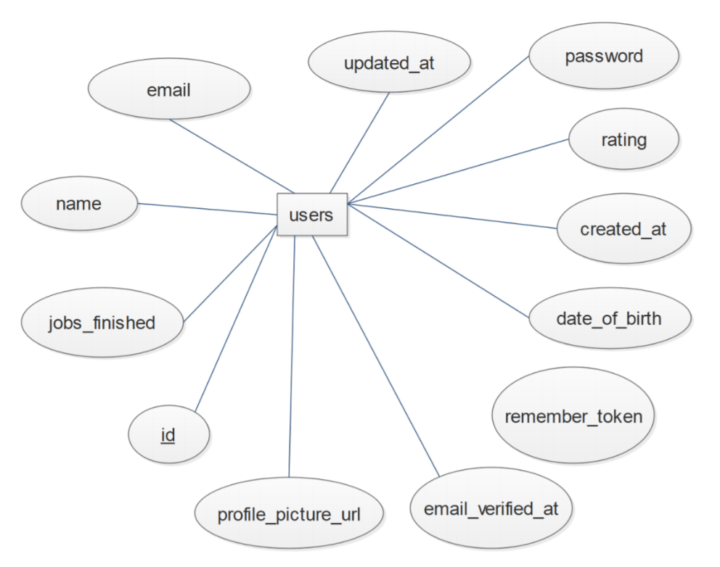

**Figure 8:** users Table Diagram

Description: The users table stores information of all the users. The “users” table is involved in a one-to-many relationship with many different tables – user_schedule, user_ip_geolocations,, ratings, conversations, conversation_messages, phone_numbers, user_job_titles, user_views, jobs, user_job_favorites, and user_recent_address.

*id:* This is the primary key for the users table. Type: Integer(11)

*name:* This is the name of the particular user. Type: Text(255)

*email:* This is the email address of the particular user.Type: Text(255)

*date_of_brith:* This is the date of birth of the particular user. Type: Date

*email_verified_at:*This is the time that the email address of the particular user was verified. Type: Timestamp

*password:* This is the password of the particular user. Type: Text(255)

*remember_token:* This is the token generated to authenticate user for resets of password. Type: Text(100)

*rating:* This is the rating score of the user. Type: Double(3,2)

*jobs_finished:* This is the number of jobs finished by the particular user. Type: Integer(11)

*profile_picture_url:* This is the profile picture url of the particular user. Type: Text(128)

*created_at:* This is the date and time the particular user account was created. Type: Datetime

*updated_at:* This is the date and time the particular user account was updated. Type: Datetime

**conversations:**

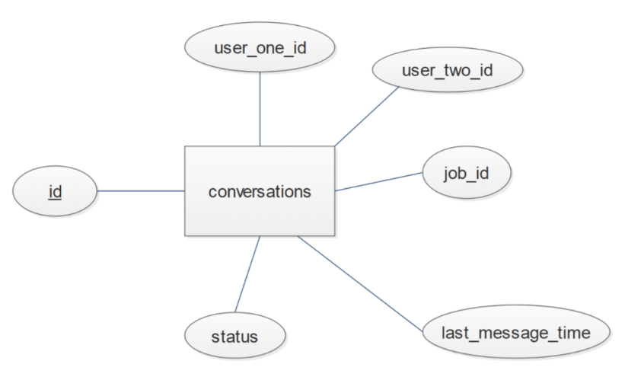

**Figure 9:** conversations Table Diagram

Description: The conversations table stores information about the users communication with a customer or other user. Each user can have several conversations with many different users. Each job can have many conversations between users. And each conversation will have many messages. The “conversations” table is involved in a one-to-many relationships with the conversation_messages table. This means that each conversation can have many messages.

*id:* This is the primary key for the conversations table. Type: Integer(11)

*user_one_id:* This is the user id one participant of the particular conversation. Type: Integer(11)

*user_two_id:* This is the user id the other participant of the particular conversation. Type: Integer(11)

*job_id:* This is the job id of the job being discussed in the particular conversation. Type: Integer(11)

*last_message_time:* This is the time that the last message of the particular conversation was sent. Type: Integer(11)

*status:* This is the status of the particular conversation. Type: Integer(11)

**conversation_messages:**

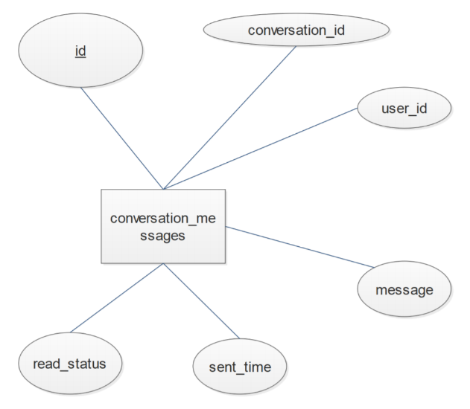

**Figure 10:** conversation_messages Table Diagram

Description: The conversation_messages table stores information about the messages of conversations between users. Each conversation can have many messages. And each user have have many messages.

*id:* This is the primary key for the conversation_messages table. Type: Integer(11)

*conversation_id:* This is the conversation id that the particular message belongs to. Type: Integer(11)

*user_id:* This is the user id that the particular message was sent to. Type: Integer(11)

*message:* This is the actual message sent. Type: Text(256)

*sent_time:* This is the date and time that the particular message was sent. Type: Datetime

*read_status:* This integer value represents whether the user has read the particular message. If the value is 0, then the user has not read the message. If the value is 1, the user has read the message. Type: Integer(1)

**ratings:**

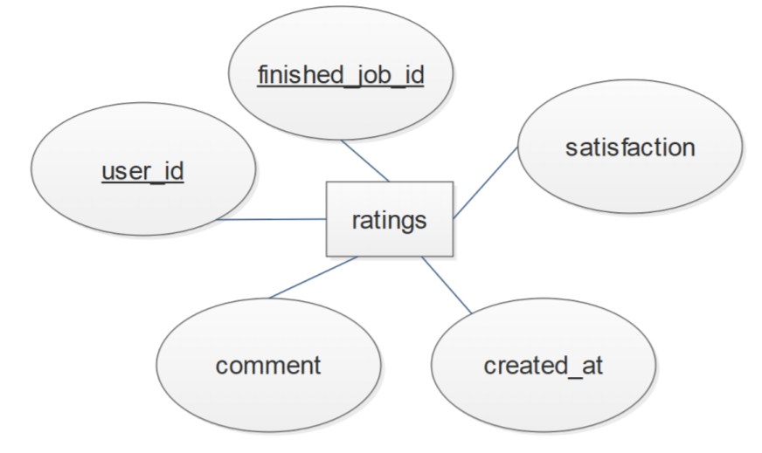

**Figure 11:** ratings Table Diagram

Description: The ratings table stores information about the user’s satisfaction with finished jobs. Each user can rate and comment many jobs.

*finished_job_id:* This is the job id of the particular finished job being rated and commented. Type: Integer(11)

*user_id:* This is the user id of the user rating and commenting the particular finished job. Type: Integer(11)

*satisfaction:* This is the rating score given by the user to the particular finished job. Type: Integer(11)

*comment:* This is the comment given by the user to the particular finished job. Type: Text(512)

*created_at:* This is the date and time the rating and comment for the particular finished job were made. Type: Datetime

**user_job_favorites:**

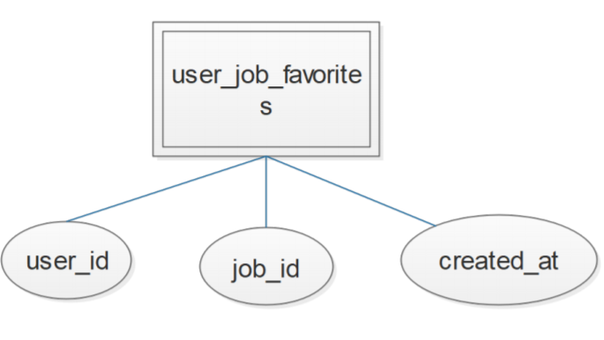

**Figure 12:** user_job_favorites Table Diagram

Description: The user_job_favorites table stores information about all the favorite jobs of the users. Each user can have many favorite jobs. And each job can be the favorite of several users.

*user_id:* This is the user id of the user that favorites the particular job. Type: Integer(11)

*job_id:* This is the job id of the favorite job of the particular user. Type: Integer(11)

*created_at:* This is the date and time that the particular user favorited the particular job. Type: Datetime

**time_slot:**

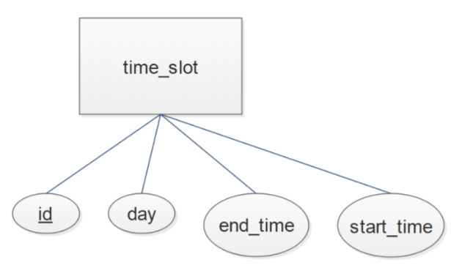

**Figure 13:** addresses Table Diagram

Description: The time_slot table stores information about all the possible or available time slots a user can be available. Each user can be available several times. And each time slot can be apply for several users. The “time_slot” table has a one-to-many relationship with user_schedule table. This means that many users can be available at the time slots.

*id:* This is the primary key for the time_slot table. Type: Integer(11)

*day:* This is the name of the day of the week for the particular time slot. Type: Text(9)

*start_time:* This is the start time of the particular time slot. Type: Time

*end_time:* This is the end time of the particular time slot. Type: Time

**password_resets:**

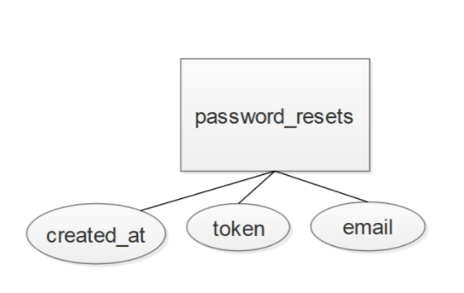

**Figure 14:** addresses Table Diagram

Description: The password_resets table stores information necessary for users to be able to reset their passwords.

*email:* This is the email address of the user that needs to change his password. Type: Text(255)

*token:* This is the token generated to authenticate the user. Type: Text(255)

*created_at:* This is the date and time that the token was created. Type: Datetime

**phone_numbers:**

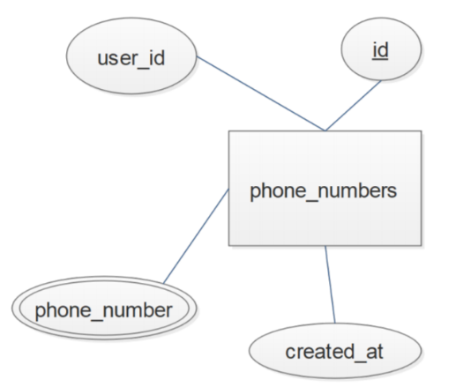

**Figure 15:** phone_number Table Diagram

Description: The phone_numbers table stores information about users’ phone numbers. Each user can have several phone numbers.

*id:* This is the primary key for the phone_numbers table. Type: Integer(11)

*user_id:* This is the user id that the particular phone number belongs to. Type: Integer(11)

*phone_number:* This is the actual phone number. Type: Text(32)

*created_at:* This is the date and time that the particular number was created. Type: Datetime

**user_search_history:**

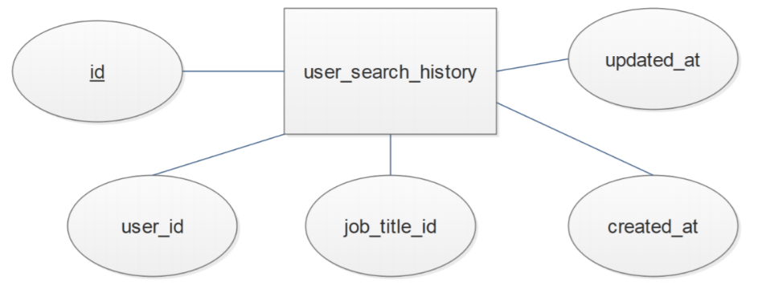

**Figure 16:** user_search_history Table Diagram

Description: The user_search_history table stores information about all the users’ searches. Each user can do several searches. The id of the job searched gets stored as well as the date and time of this specific search.

*id:* This is the primary key for the user_search_history table. Type: Integer(11)

*user_id:* This is the user id of the user doing the particular search. Type: Integer(11)

*job_title_id:* This is the id of the job title of the particular search. Type: Integer(11)

*created_at:* This is the date and time of when the particular search was made. Type: Datetime

*updated_at:* This is the date and time of when the particular search was updated. Type: Timestamp

**jobs:**

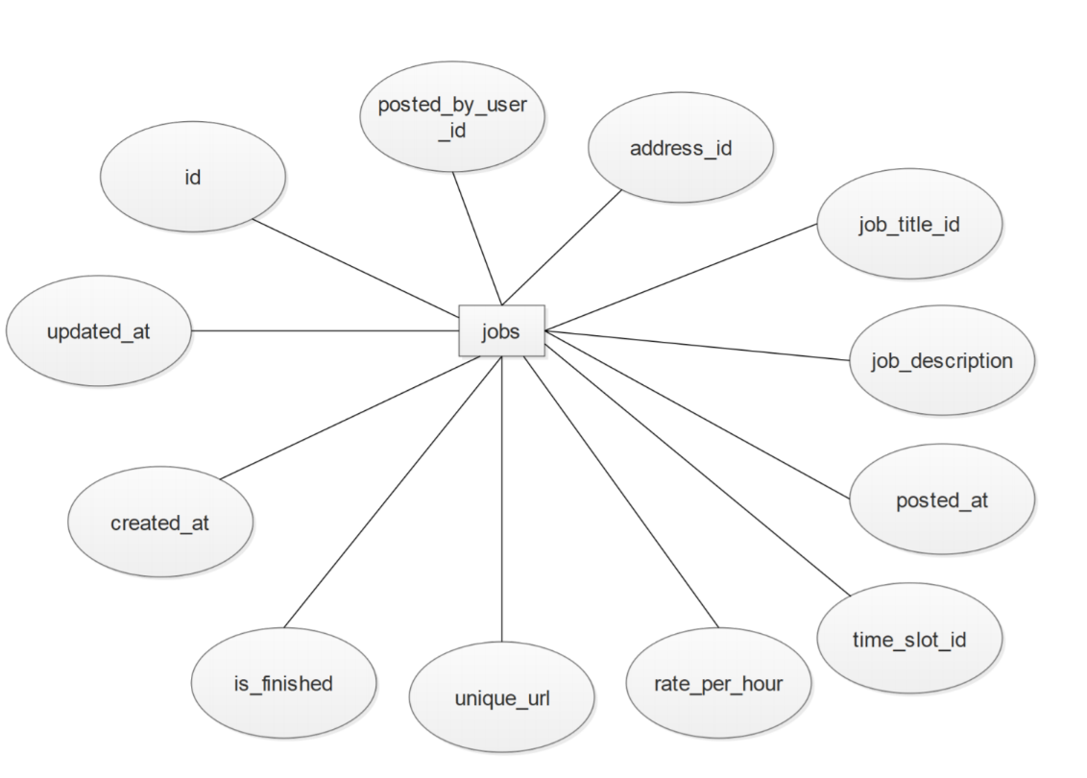

**Figure 17:** jobs Table Diagram

Description: The jobs table stores information of each job posted by a user. Each user can post many jobs. Each job title, address, and time slot can be applicable for many jobs. And each job can have many images and be favorited by many users.

*id:* This is the primary key for the jobs table. Type: Integer(11)

*posted_by_user_id:* This is the user id of the user that posted the particular job. Type: Integer(11)

*address_id:* This is the address id of the address for the particular job. Type: Integer(11)

*job_title_id:* This is the job title id for the particular job. Type: Integer(11)

*job_description:* This is a description of the particular job. Type: Text(2048)

*posted_at:* This is the date and time the particular job was posted. Type: Datetime

*time_slot_id:* This is the time slot id that the particular job Type: Integer(11)

*rate_per_hour:* This is the salary per hour for the completion of the particular job. Type: Double

*unique_url:* Type: Text(128)

*is_finished:* This integer value represents whether the particular job has been completed or not. If the value is 0, the job has not been finished. If the value is 1, the job has finished. Type: Integer(1)

*created_at:* This is the date and time that the particular job was created. Type: Datetime

*updated_at:* This is the date and time that the particular job was updated. Type: Datetime

**job_images:**

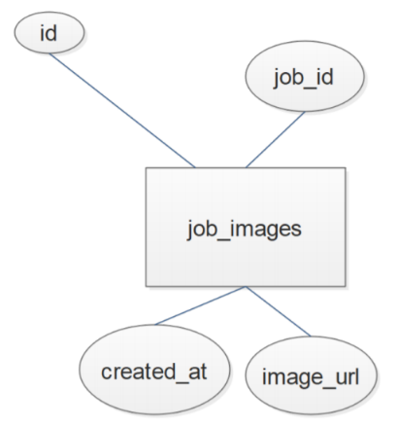

**Figure 18:** addresses Table Diagram

Description: The job_images table stores information icons or images that describe the jobs. Each job can have many images.

*id:* This is the primary key for the job_images table. Type: Integer(11)

*job_id:* This is the job id of the image job of the particular job. Type: Integer(11)

*image_url:* This is the url of the image of the particular job. Type: Text(128)

*created_at:* This is the date and time of when the image was created. Type: Datetime

**job_titles:**

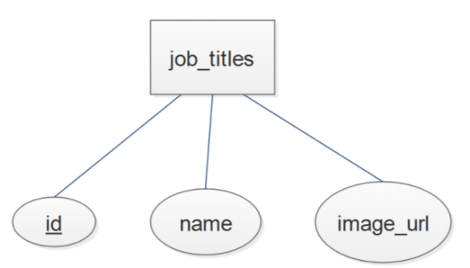

**Figure 19:** addresses Table Diagram

Description: The job_titles table stores information of the titles for each job. Each job can have many names or images.

*id:* This is the primary key for the job_titles table. Type: Integer(11)

*name:*  This is the name of the particular job. Type: Text (256)

*image_url:* This is the url of the image of the particular job. Type: Text(128)

**promoted_jobs:**

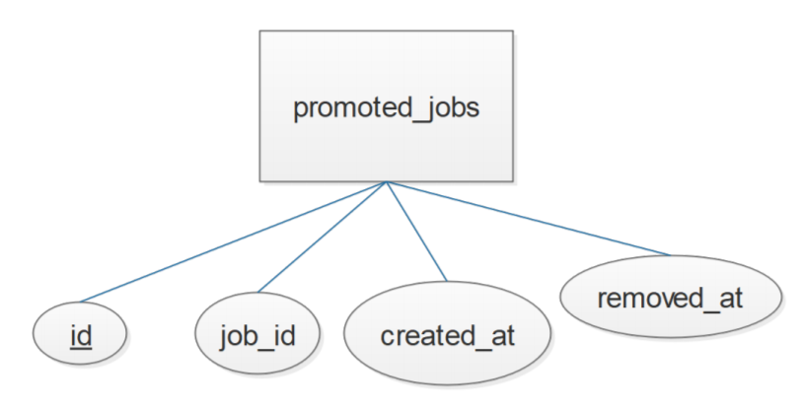

**Figure 20:** addresses Table Diagram

Description: The promoted_jobs table stores information of the job being promoted. Each user can promote or remove many jobs.

*id:* This is the primary key for the promoted_jobs table. Type: Integer(11)

*job_id:* This is the id of the job being promoted. Type:Integer(11)

*created_at:* This is the date and time of when the promoted job was created. Type: Datetime

*removed_at:* This is the date and time of when the promoted job might have been removed. Type: Datetime

**user_job_titles:**

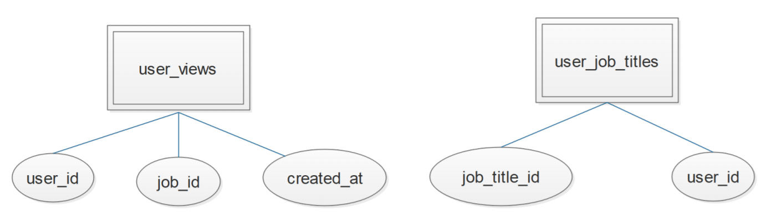

**Figure 21:** addresses Table Diagram

Description: The user_job_titles table stores information of the user and its respective jobs. Each user id can have multiple jobs.

*user_id:* This is the user id that the particular job title belongs to. Type: Integer(11)

*job_title_id:* This is the job title id of the users’ particular job. Type: Integer(11)

**user_views:**



**Figure 22:** addresses Table Diagram

Description: The user_views table stores information of the views each user has had respect to the job, as well as the date and time this view occurred.

*user_id:* This is the user id that the particular view belongs to. Type: Integer(11)

*job_id:* This is the job id that the particular view belongs to Type: Integer(11)

*created_at:* This is the date and time of when the view occurred. Type: Datetime

**admins:**

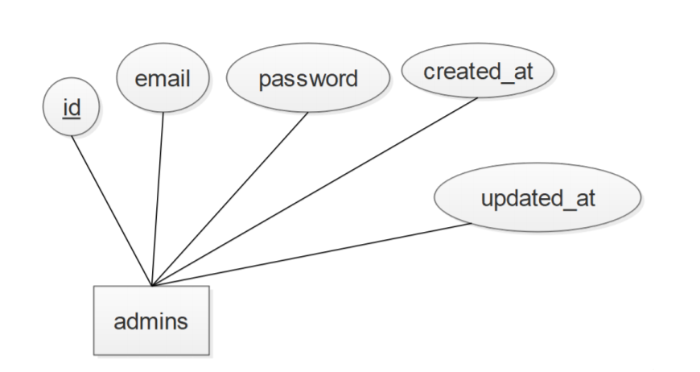

**Figure 23:** addresses Table Diagram

Description: The admins table stores information of the application’s administrative user accounts.

*id:* This is the primary key of the admins table. Type: Integer(11)

*email:* This is the email address of the particular administrative user account. Type: Text(64)

*password:* This is the password of the particular administrative user account. Type: Text(256)

*created_at:* This is the date and time the particular administrative user account was created. Type: Datetime

*updated_at:* This is the date and time the particular administrative user account was updated. Type: Datetime

**finished jobs:**

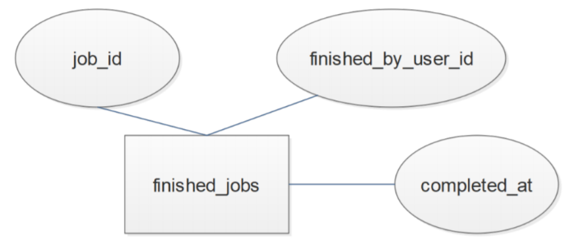

**Figure 24:** addresses Table Diagram

Description: The finished_jobs table stores information of each finished job. Each job can be finished. And each finished job can be rated.

*job_id:* This is the job id of the particular finished job. Type: Integer(11)

*finished_by_used_id:* This is the user id of the user that finished the particular finished job. Type: Integer(11)

*completed_at:* This is the date and time the particular finished job was finished. Type: Datetime